Work Done by a Constant Force:

Write the definition of Work done by a constant force F, if the displacement is d, and the angle between F and d is $θ$:

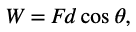
—------------------

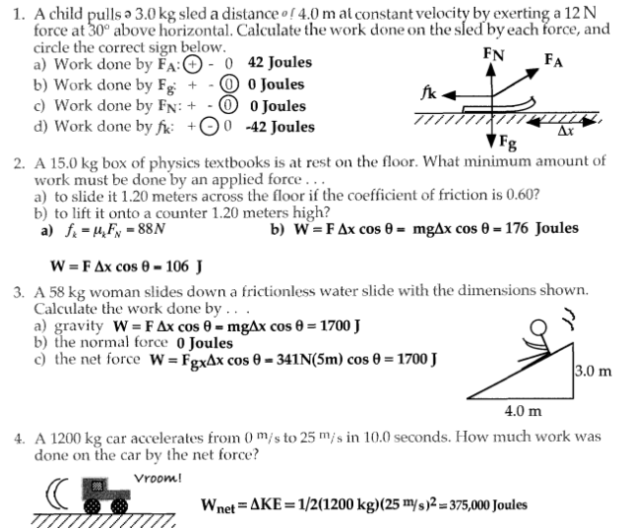
\

Positive and Negative Work Done
 θ is the angle between the force vector F and the displacement vector d.

If $0^{o}$ <= θ < ${90}^{o}$ Cosθ > 0, Work done is positive,
If ${90}^{o}$ < θ <= ${180}^{o}$ Cosθ <0, Work done is negative,
If θ = ${90}^{o}$ , Cosθ = 0, Work done is zero.
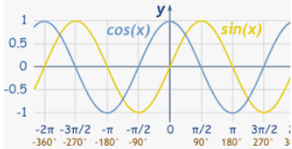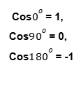

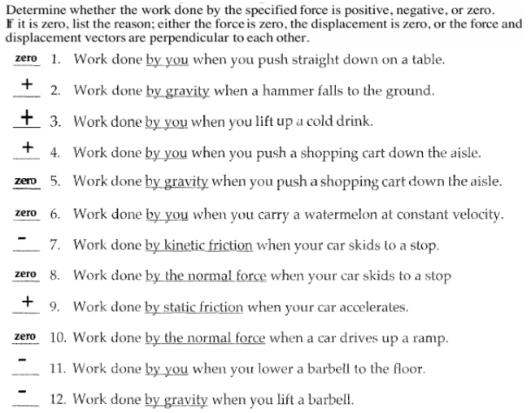

Kinetic Energy: Write the definition of Kinetic Energy of an object with mass m and speed v:
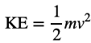

The Work-Energy Theorem: Write the equation of Work-Energy theorem:
